## Step 1: Define Your Audience/Tone

20 minutes  
Answer the following questions in a document:

* Who will visit your site? Potential employers? New clients or customers?

**The site’s target audience is those who participate in extreme sports, and have a deep appreciated for nature and the environment around them. The site will also be visited by both instructors and those in the business of extreme sports. It will serve as a place for them to advertise for and promote their businesses.**

* What can make you and/or your product stand out against your competitors?

**This site will almost serve as a yelp for extreme sports enthusiasts, a visually glorious location for these sportsmen and sportswomen to share in a community of like-minded, adrenaline junkies.**

* How would you speak to your clientele if you were communicating in person? How could you translate that style and tone digitally?

**Because it is geared toward those who love risky sports and everything that goes along with it, the site will betray an understanding of the endeavour, and desire to risk everything, all in an effort to get closer to the ethereal that the sky, ocean, and mountains have to offer. Rich, inspiring pictures and videos, chronicling the most amazing adventures and feats will be all over the site, allowing visitors to relive the sportspeople’s most memorable moments. The site will also serve as a resource for this community, inspiring them with new locations and ways to accomplish amazing feats, whether it be in skydiving, deep sea exploration, bungee jumping, hang-gliding, peak summiting, BMX biking, etc. The site needs to convey that all the work, stress, gear and exertion needed to get there is worth it – even if only for a few moments of serenity and peace, with the appreciation of the purest of what nature has to offer.**

* What colors represent you or your product?

**The visual vocabulary will need to portray two completely different vibes: one of adrenaline and adventure, and one of peace and the ethereal, after summiting a mountain and looking around, getting to the bottom of a seascape and contemplating the view, etc. If anything, the site will lean towards the calming blues, more emphatic blues, as well as earth tones.**

* What images illustrate your message?

**Images used will include incredible seascapes, landscapes, from around the world, and personal albums outlining war stories, outlining the journey it took to get to that coveted point.**

**Step 2: Identify Content**

*20 minutes*  
Create a sitemap in outline format of your website in the same document. Use the following questions as a guide:

* What are the three-to-five pages titled?  **Air (for sports like hang gliding, skydiving, etc.), Water (deep sea diving, deep sea fishing, submarine exploration), Land (repelling, cave exploration, summiting peaks, outrageous snowboarding, BMX riding). Air, Water and Land will be a place where sportspeople can post their own videos and photos, with captions, and relive those of other users. Experience is a resource for finding the sport you want, where to do it, how. Connect is a section where the user can find instructors, team members, etc.**
* What will be the purpose for each**?** What should each page contain? Will there be textual content? Or just images? **Air, Water and Land should be very image rich and inspire. Experience and Connect should be visual, but house forms for inputting and getting what you want.**
* *Helpful Hints:
* You can use your sketches from Unit 2 or build upon the restaurant site in Unit 3 for inspiration, so that you don’t feel like you’re recreating the wheel!
* Use [this document](https://docs.google.com/document/d/1OfIuvDPY0mN24j-xC5j4KZ7dsPzMqkCIhIvjdMQnDnY/edit?usp=sharing) as a reference for setting up your content.

Logo

Style Guide

Typography

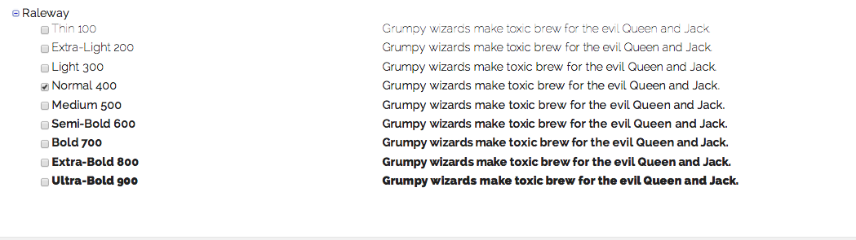

HEADER 1-6

COLORS:

